WMT River System Development

Comparison of Available Devices and Protocols

Sensor Types
This is a subset of the variois sensor types that have been identified, but includes all of the viable types that do not cost more than a few tens of pounds to implement.

Note: Analogue to Digital Converters (A/Ds) are available as detailed in the Section on Sensor Interfaces below. Unless a home made A/D is employed the costs of the commercial types must be added to the prices given in the Table below.
Device - > | HC-SR04 | Probe Rods | Capacitance | Float | Pressure | Weight
Type | Level | Level | Level | Level | Level | Level
Technology | Ultrasonic Range | Conduction | Change of C | Microswitch | Air pressure | Weight of Butt
Pros | Cheap, simple, linear, existing Libraries | Cheap, simple, can use GPIO | Fairly cheap | Cheap, simple, can use GPIO | Fairly cheap, linear. | Fairly cheap, linear.
Cons | Difficult to protect from moisture/ice. | Coarse Measurement | Needs RF stimulus | Coarse Measurement | Needs pre-amp and A/D | Needs pre-amp and A/D
Price | £1.57 | Home-made. A few poinds for materials. | Home-made; cost difficult to estimate. | £5 to £25, depending on the number of floats. | ~£10 + A/D. | ~£10 + A/D.

Sensor Types Continued

Device - > | VL53L0X | Paddle | Paddle | Vane
Type | Level | Flow | Flow | Flow
Technology | Laser Range Finder | Hall Effect | Tacho-gen | Potentiometer
Pros | Linear, existing Libraries | Linear | Linear | Simple, cheap
Cons | Difficult to protect from moisture/ice |  | Probably have to make generator. | Non-linear, pot can wear. Needs A/D
Price | £15 | ~£5 | ? | ~ £1 + A/D

Devices for Sensor Interfaces and Data Processing

Device - > | Raspberry Pi Zero | Raspberry Pi 3 | Arduino Uno | ADC Pi Plus | ADC Pi Plus | RaspIO Analog Zero
Microcontroller | BCM2835 | BCM2837 (Quad Core) | Atmega328 | NS | Ditto | Ditto
Operating Voltage | 5 V | 5 V | 5V | GPIO Header | Ditto | Ditto
Input Voltage (recd) | N/A | N/A | 7-9V | NS | Ditto | Ditto
Input Voltage (limits) | N/A | N/A | 6-20V | NS | Ditto | Ditto
Digital I/O Pins | 26 | 26 | 14 (6 provide PWM) | GPIO (pass through) | Ditto | Ditto
Analogue Input Pins | 0 | 0 | 6 | 8 | Ditto | Ditto
Analogue Voltage Range | N/A | N/A | 0 to 5 V (can be extended) | 0 to 5 V | Ditto | 0 to 3.3 V
Resolution (bit) | N/A | N/A | 10 | 17 | Ditto | 10 (can ext to 12)
Conversion time | N/A | N/A |  | 240 SPS | Ditto | NS
DC Current per I/O Pin | N/A | N/A | 40 ma | 2 mA | Ditto | NS
DC Current for 3.3V Pin | N/A | N/A | 50 mA | N/A | Ditto | NS
Flash Memory | N/A | N/A | 32 KB (0.5 KB bootloader) | N/A | Ditto | Ditto
SRAM | 512 MB | 1 GB | 2 KB | N/A | Ditto | Ditto
EEPROM | NS | NS | 1 KB | N/A | Ditto | Ditto
Clock Speed | 1 Gb/s | 1.2 Gb/s | 16 MHz | NS | Ditto | Ditto
Other Features | HDMI, 1 USB Port, Camera Port | HDMI, 4 USB, Port, Camera Port, Audio Jack | 2 hardware Interupts, 6 8-bit PWM O/Ps | On board Programmable Amplifier (up to 8 X) | Ditto | Small prototyping area.
Comms | 1-Wire, I2C, SPI, GPIO | 1-Wire, I2C, SPI, GPIO, Ethernet, 802.11n WiFi | UART, I2C, SPI | I2C | Ditto | SPI
Price | £4 | £30 | £11 | £15.99 | £14.99 | £10

Dual Slope Analogue to Digital Converter
The last three items in the table in the previous Section are all traditional Aanalogue to Digital converters. They make it easy to code the functions, because support Libraries are provided. A cheaper alternative could be to use a single or dual-slope converter, as was used in traditional DMMs.
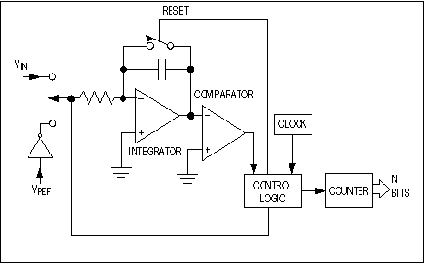
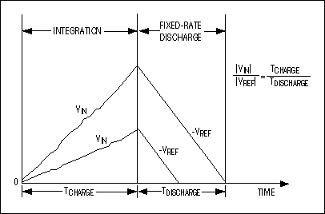
In this device, an analogue integrator is used with switched inputs, a comparator, and a counter unit. The input voltage is integrated for a fixed time interval (TCHARGE) that usually corresponds to the maximum count of the internal counter unit (Figure 4). At the end of this interval the device resets its counter and applies an opposite-polarity (negative) reference to the integrator input. With this opposite-polarity signal applied, the integrator "deintegrates" until its output reaches zero, which stops the counter and resets the integrator.
Charge gained by the integrator capacitor during the first, integrating/charging interval (TCHARGE/|VIN|) must equal that lost during the second, deintegrating/discharging interval (TDISCHARGE/|VREF|). Then the binary output is proportional to the ratio of these time intervals relative to the full count. TDISCHARGE at the end of the second interval corresponds to the ADC's output code.
Fuller details of the technique may be found at Analogue to Digital Converters.
The electronics could be realised using Op-amps and analogue multiplexers (for dual-slope) with on-board or external clocking. The Pi could be used to count the time and calculate the voltage and therefore the level. Alternatively, the Pi could simply trigger the measurement and read the count on its I/O pins.
This may end up more expensive than the bought-in A/D boards, but would be more educational.

